**REPORT ON INTERNSHIP WORKS**

|  |  |
| --- | --- |
| **Name** | **R NIRMAL** |
| **Roll.no** | **727621BAD012** |
| **College** | **Dr. MCET POLLACHI.** |
| **Date** | **19.06.2023 – 01.07.2023** |
| **Company Name** | **Deep2Neuron Tech Academy** |
| **Department** | **Artificial Intelligence and Data Science** |

**INDEX**

|  |  |  |  |
| --- | --- | --- | --- |
| **S.no** | **Date** | **Day** | **Page no.** |
| **1** | **19.06.2023** | **Day-1** | **2-3** |
| **2** | **20.06.2023** | **Day-2** | **4-7** |
| **3** | **21.06.2023** | **Day-3** | **8-11** |
| **4** | **22.06.2023** | **Day-4** | **12-14** |
| **5** | **23.06.2023** | **Day-5** | **15-17** |
| **6** | **24.06.2023** | **Day-6** | **18-21** |
| **7** | **25.06.2023** | **Day-7** | **22-27** |
| **8** | **26.06.2023** | **Day -8** | **28-31** |

**DAY-1**

**Introduction:**

Internship starts with choosing a project and dataset which should be a CNN model and we have obtain the output for that program.

**Activities assigned:**

* Need to choose the project and its title.
* Need to choose respective CNN algorithm that suits for the dataset.
* Want to get code from online sources.
* Need to run the code in Colab and get the accuracy.
* Need to create a GitHub public repository for updating regular progress .

**Activities Completed:**

* Project: Forest fire Detection (Image Dataset).
* Taken CNN algorithm but couldn’t get the result.
* Algorithm analysis run successfully but performance was not completed.

**Challenges & Doubts:**

* The dataset that I used in this project was downloaded in colab while running the project.
* Running code in Colab has disadvantage of connecting the Kaggle or downloading dataset uploading and getting data processed which is simplified by Kaggle.
* Got difficulty in clearing the “name error”.

**Screenshots for Day – 1**

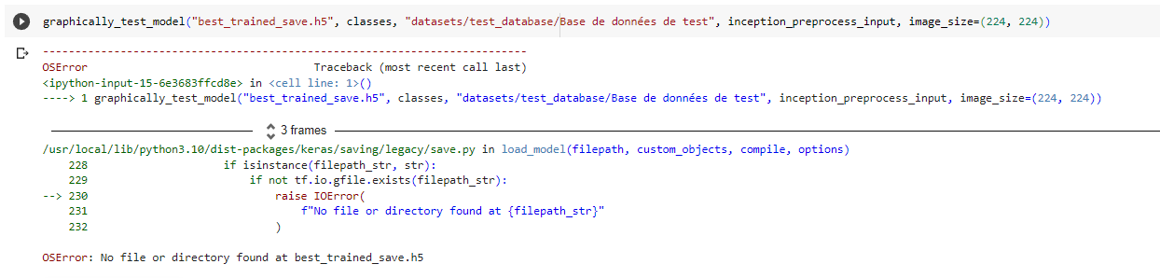

**Conclusion:**Many difficulties were faced even though the code and dataset was taken from online especially in running and clearing the error

**DAY-2**

**Introduction:**

The day mainly focuses on creating our own dataset which includes collecting, cleaning and uploading the dataset. Then finding the appropriate CNN model to train the dataset.

**Activities assigned:**

* Need to choose the project related to Image classification.
* Need to collect the images from online.
* Need to make the folder structure with Test which consists of 50 images in each folder, Validation of 30 Images in each folder and Train Images which is remaining.
* Total number of Images includes more that 300 images.
* Need to upload the dataset in Drive and mount it in colab with GPU backend.

**Activities Completed:**

* Project: Image classification of Dog with CNN.(Multiclass)
* Code has been given during the meeting and changes has been made to our code accordingly.
* Code ran in Colab has successfully run with 20 epochs and plotted graph for the training loss, validation loss, Training accuracy and validation accuracy.
* Image has been tested for its prediction.
* Learned about Binary and Multiclass and what are changes to be made if it is binary or multiclass has been known from the meeting.
* Changes must be done in code for multi class and binary class.

**Challenges & Doubts:**

* The predicted label is wrong when compared with the actual model.
* The number of epochs ran in the model is not sufficient for the model to predicate the image.

**Screenshots for Day – 2**

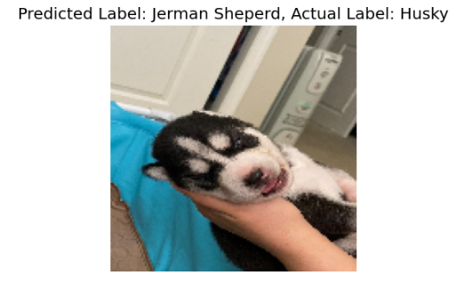

Result is not correct

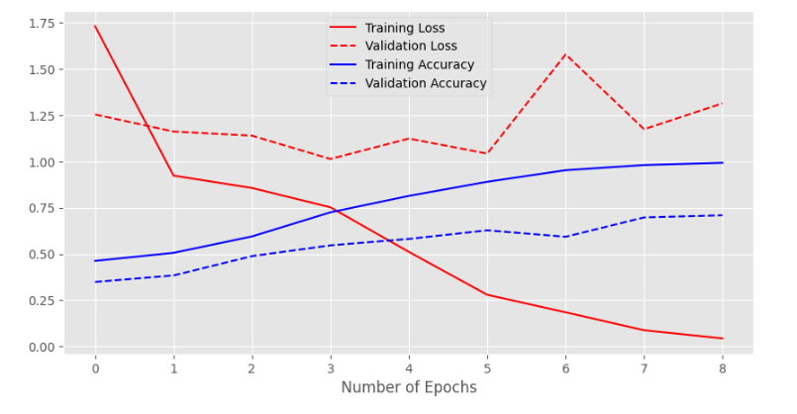

**Graph plotting accuracy and loss**

**Conclusion:**Learned about creating and cleaning a dataset. Types of datasets used in image classification. Able to clear the errors in the code.

**DAY-3**

**Introduction:**

Internship includes the process of downloading data given by the instructor and need to upload and train the model using CNN as it is a Image classification problem.

**Activities assigned:**

* Need to download and upload given Exam Data
* Need to apply CNN code based on past learnings and identify class accordingly and make changes according to the classes.
* Need to run the code for 20 epochs .

**Activities Completed:**

* There 5 types of classified images sets in dataset. Then we used the train and validation for training the model.
* I have used Validation 2 as my test data and trained the model and plotted the confusion matrix, respectively.
* Confusion matrix was created for the trained model.

**Challenges & Doubts:**

* Faced difficulty in uploading the dataset in the drive. Network error was faced during the uploading time.

**Screenshots for Day – 3**

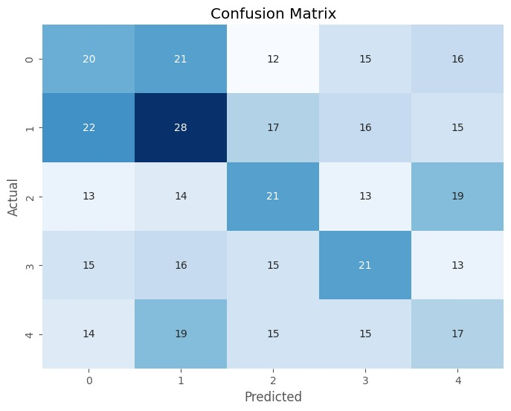

**Confusion matrix with class**

**Conclusion:**

Ended the day with solving the doubts in network error. Then working in the project got a bit later due to uploading problem.

**DAY-4**

**Introduction:**

Made corrections in the confusion matrix and learnt about the neural network.

**Activities assigned:**

* Need to run code for 20 epochs at least and plot training and accuracy matrix.
* Need to run our code on local system and either download and make code work in local system.

**Activities Completed:**

* I run the code in pycharm.
* It took me time to run the code and the code was partially executed.

**Challenges & Doubts:**

* Faced difficulty in executing the code in local system because of system of low configuration.
* Setting the local system for executing the project,

**Screenshots for Day – 4**

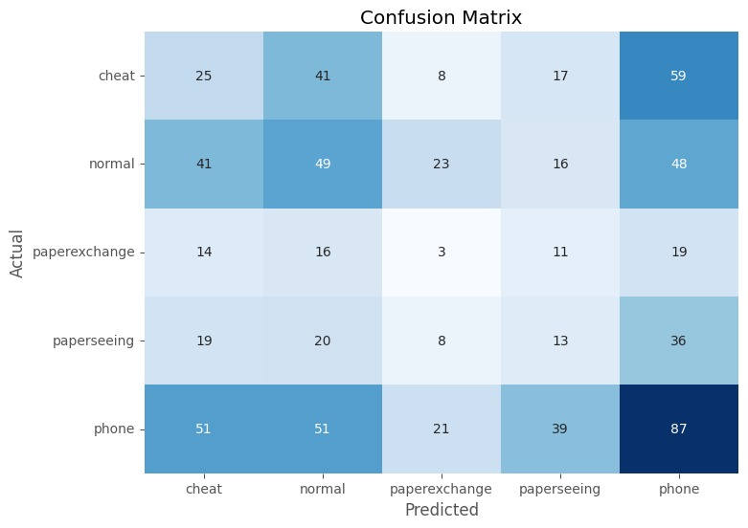

**Confusion matrix with class names**

**Conclusion:**Day has been concluded with training the model with same code in the local system and has better clarity to set paths and rectify errors in local system.

**DAY-5**

**Introduction:**

Various tasks were assigned to execute a given dataset in different in algorithms.

**Activities assigned:**

* Need to download the new architecture dataset.
* Need to run code with pretrained model and need to make better model.
* Algorithms can be referred from https://www.tensorflow.org/api_docs/python/tf/keras/applications/densenet/DenseNet169

**Activities Completed:**

* Downloaded and learned about dataset.
* It was dataset with 10 classes and found it was multiclass.
* The images are in smaller size so learning process took.
* Changed accordingly the parameters and run code for VGG 16 pretrained model with 0.01 learning rate with 100 epochs and batch size of 128 and achieved accuracy of 87 percent approximately.

**Challenges & Doubts:**

* It took a while to understand the code and modify the code.
* Got the confusion matrix and it has good prediction.
* After running 100 epochs gave an output of 0.92 accuracy level.

**Screenshots for Day – 5**

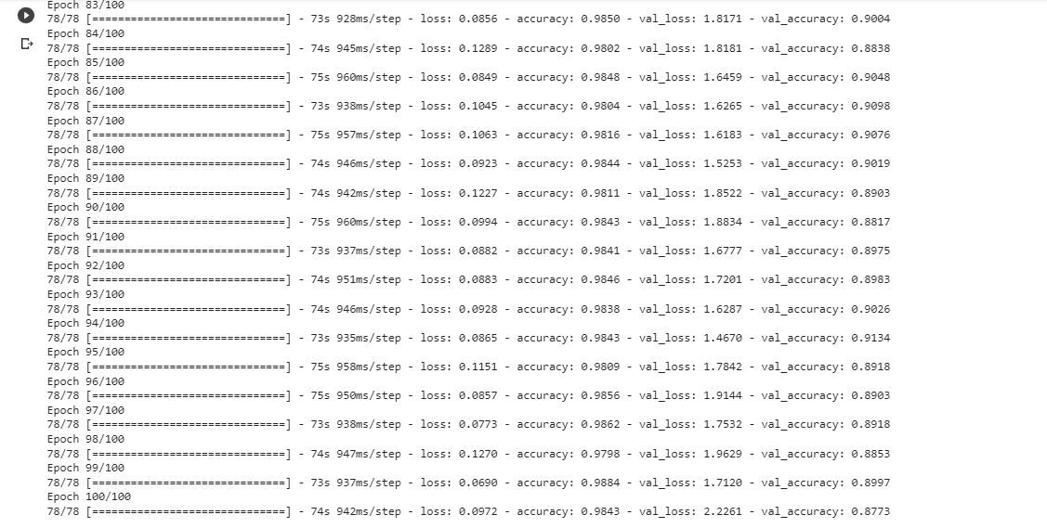

**Trained model**

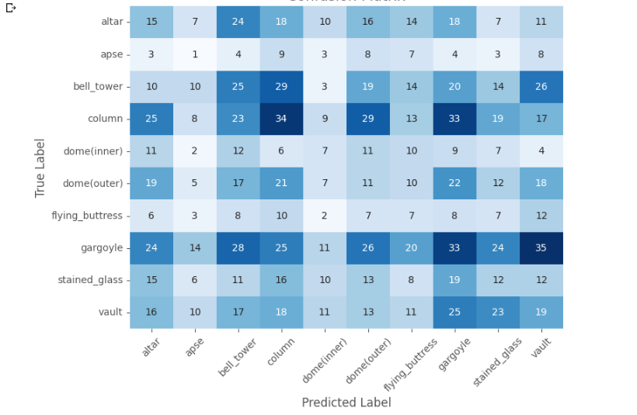

**Confusion matrix with class names**

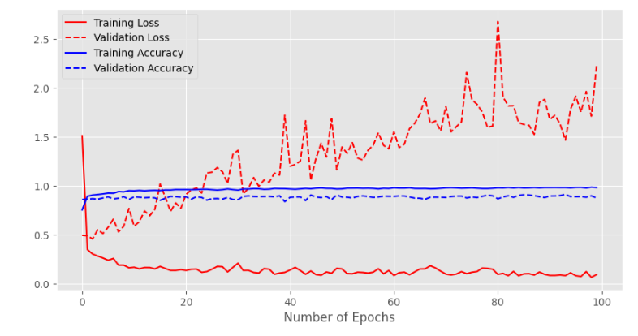

**Graph plotting accuracy and loss**

**Conclusion:**Day has been concluded with training the model with same code in the local system and has better clarity to set paths and rectify errors in local system.

**DAY-6**

**Introduction:**

Day started with working on resnet algorithm and modifying VGG code accordingly.

**Activities assigned:**

* Wanted to run resnet50 or any pretrained model code and made a detailed report for it.

**Activities Completed:**

* Trained a resnet model with 100 epochs which took 6 hours of time which indicates that model struggled to learn the data and fit in it.
* The model has trained with the parameters of 0.01 learning rate with 128 batch size.
* It gave an accuracy of 0.92 which is quite good but it has not reflected in confusion matrix which was slight disadvantage.

**Challenges & Doubts:**

* This took a lot to time to train the model .

**Screenshots for Day – 6**

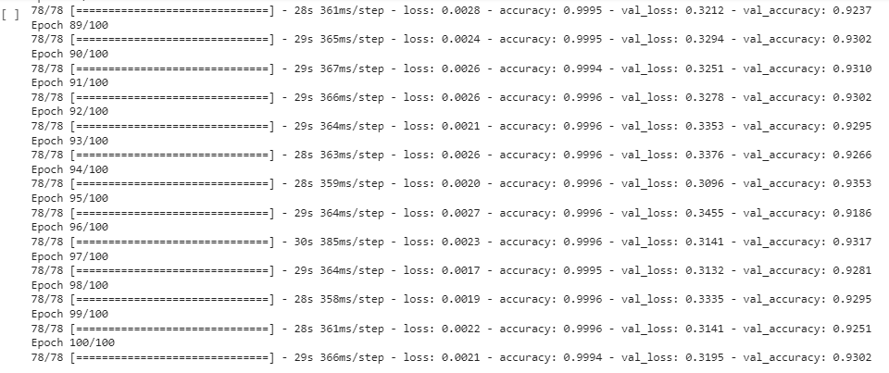

**Resnet50 Trained model**

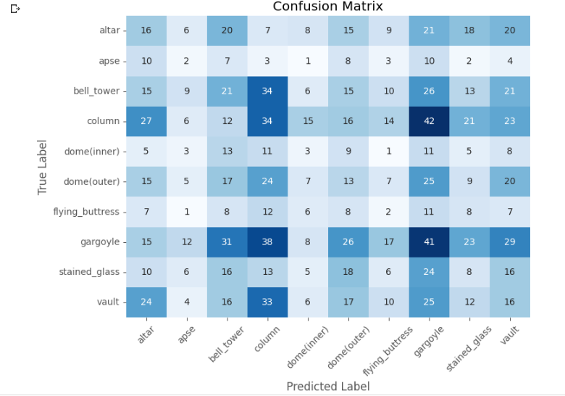

**Confusion matrix with class names**

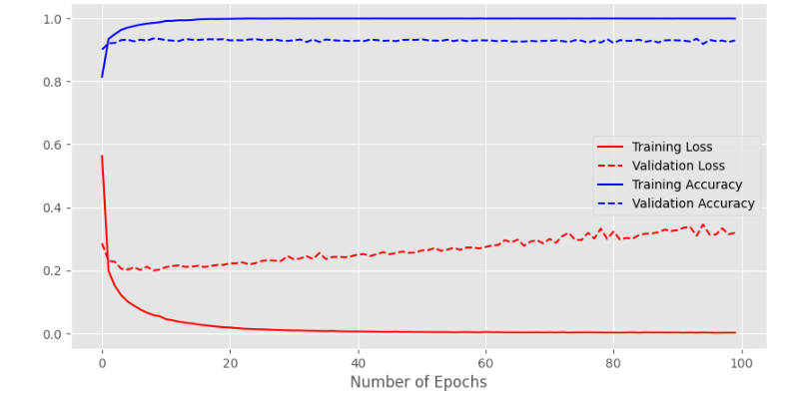

**Graph plotting accuracy and loss**

**Conclusion:**Day has been concluded with training the model with pretrained architectures with different outputs and results.

**DAY-7**

**Introduction:**

Day started with working on Base CNN model.

**Activities assigned:**

* Wanted to run Base CNN model code and made a detailed report for it.

**Activities Completed:**

* Need to run the train the model.
* I have set the learning rate to 0.01 and the batch size to 128.

**Challenges & Doubts:**

* Base CNN executed without any difficulties.

**Screenshots for Day – 7**

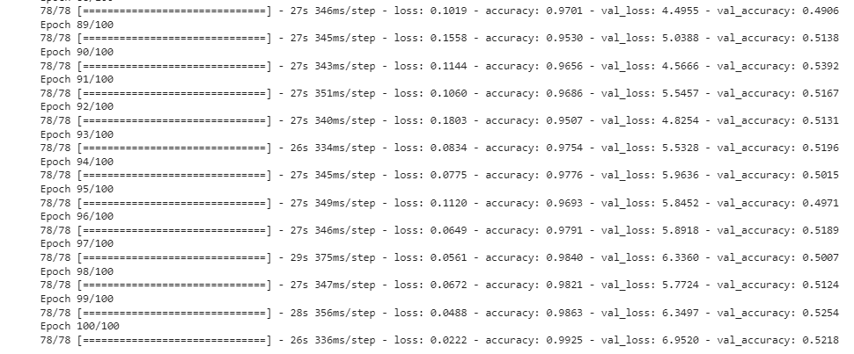

**Running Epochs**

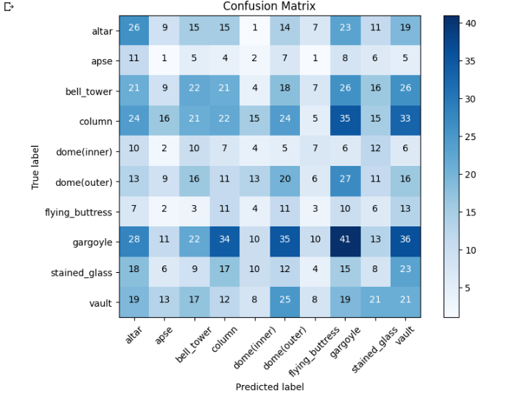

**Confusion Matrix**

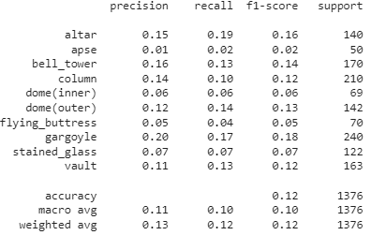

**Classification Report**

**Conclusion:**Concluding the works with the accuracy of minimal which must be fine-tuned to get better results to reach the overall better accuracy.

**DAY-8**

**Introduction:**

Introduction to image recognition and plotting was given.

**Activities assigned:**

* Need to Complete Documentation for that week which is assigned previously(Complete image classification).

**Activities Completed:**

* Need to study about the image recognition process(image annotation).

**Challenges & Doubts:**

* Completed the documentation process and the self study was done..

**Conclusion:**Concluding the works with the better accuracy for Happy or sad classification dataset and still working with vgg19 to get a better result and finetuning model.